Downloads in Funded Early Learning - Doc link: [Funded Early Learning | Sheffield Directory](https://www.sheffielddirectory.org.uk/kb5/sheffield/directory/advice.page?id=_dg8Dvgg5Zc)

To view your “30 Hours” code or to reconfirm eligibility, you will need to access your Childcare Service Account.

* Go to the Childcare Service website: <https://childcare-support.tax.service.gov.uk/>  
    
  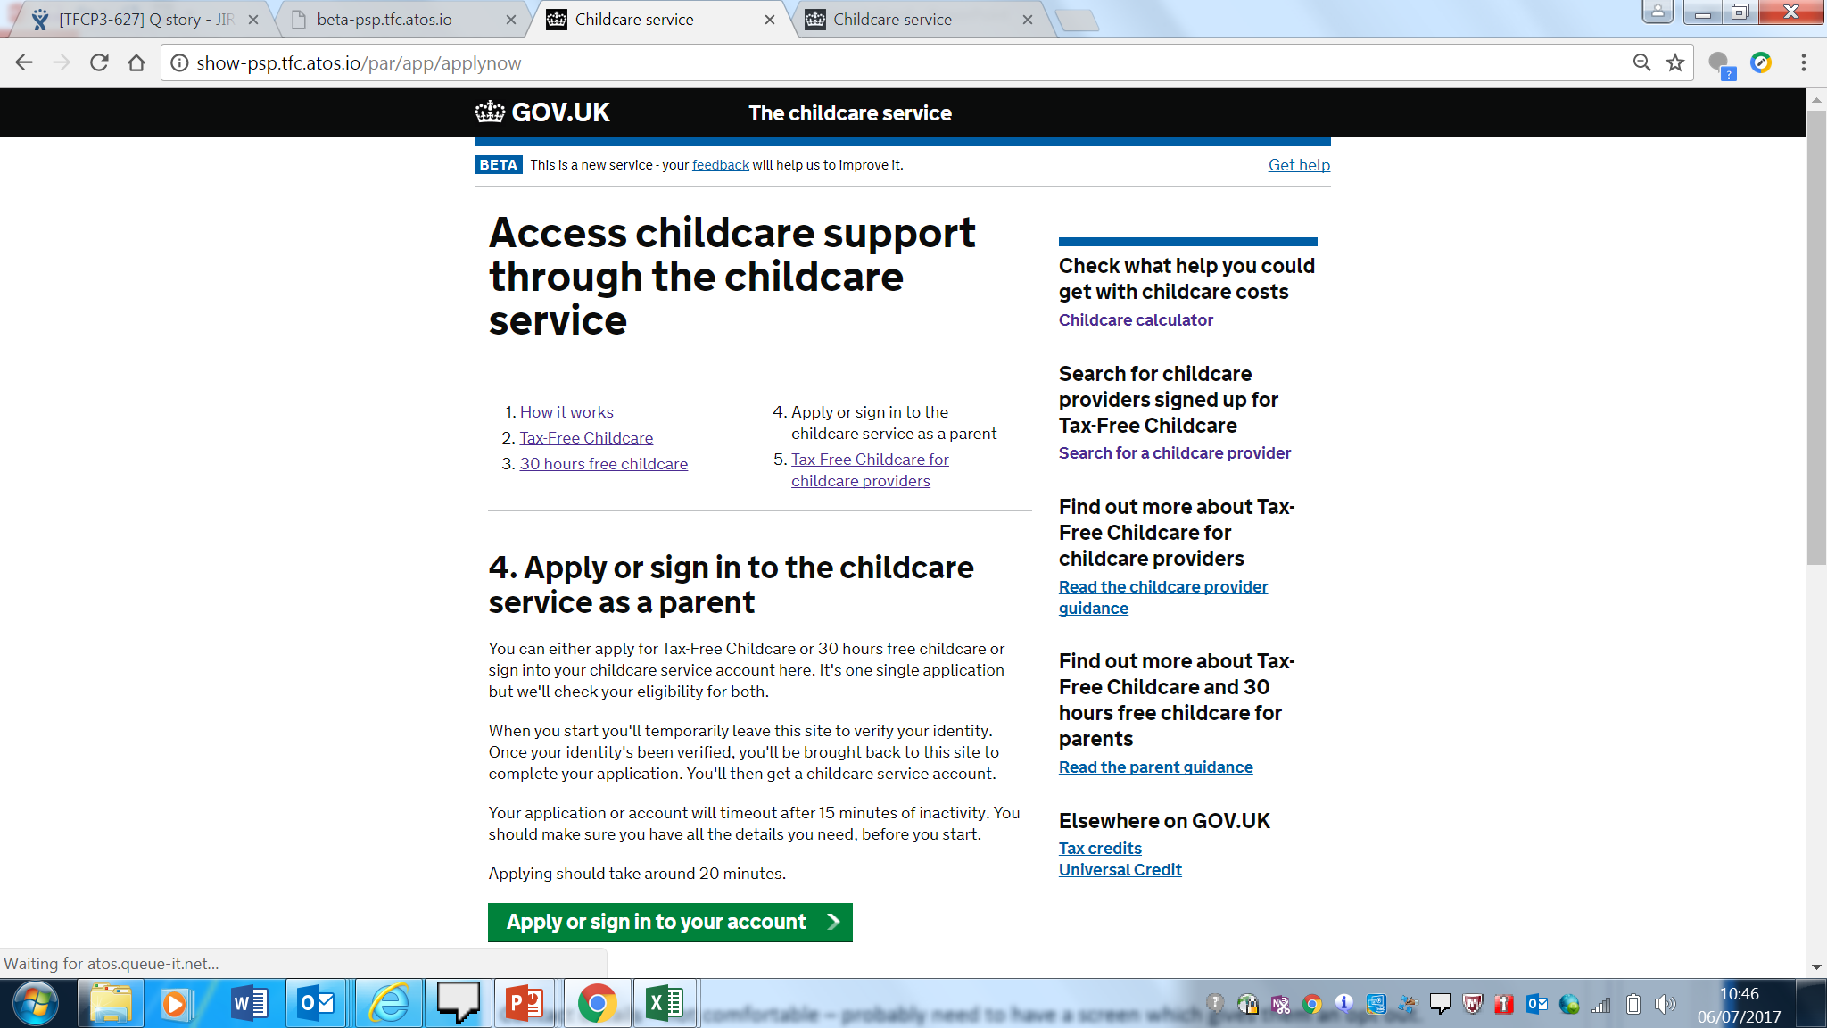
* Click on the green button to sign in to your account.
* Sign in using your Government Gateway ID – you will have used this when you first applied.
* You will now go to your Childcare Service account screen.

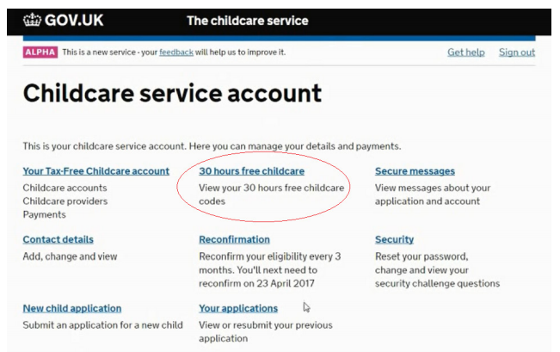

* Once you have opened the Childcare Service account screen, click on “30 Hours free childcare” to see your eligibility code. Your childcare provider will need this code to be able to confirm your child’s place.
* Click on Reconfirmation to reconfirm eligibility. You must do this every three months.
* You can reconfirm eligibility up to 4 weeks before your reconfirmation date.
* You should get a text and/or email from HMRC 4 weeks before your reconfirmation deadline.
* You will keep the same code, but it will be extended for another 3 months from the current end date.
* If your circumstances have changed, you will need to update your details.
* If your first application was by phone, you will need to reconfirm by phone too.
* If you were issued with a temporary code (one that starts with 11), you will have to complete a new application to get a permanent code (one that starts with 500).
* If you miss the reconfirmation deadline you will need to reconfirm before the grace period runs out, or you may lose the funded hours.
* You can also view the code or reconfirm by clicking on the Secure Messages section.