**SHEFFIELD EARLY HELP ASSESSMENT FORM**

***Guidance Notes***

**Introduction**

The Sheffield Early Help Assessment has been in development since 2020, with over 1000 frontline practitioners, senior leaders and partner agency representatives consulted on it’s development, including the SCSP LPIG members, all the SCC Early Help and Children’s Social Care Workforce, all School Safeguarding Leads, Early Help Service Managers, CAMHS Managers plus all recipients of the Early Help Partnership Training offer.

The final consultation ended on 17th September 2023. Feedback was overwhelmingly positive, and most suggested additions or amendments were incorporated.

The form and implementation timetable was approved by the Early Help Strategic Partnership Board on 28th September 2023.

The new form, guidance notes and training will be launched in December 2023, with the recognition that agencies will need a window of time from to become familiar with the new form and stop using the FCAF, Early Help Part 1 form and other Early Help Referral forms.

From 1st April 2024 all Early Help Services should be using the new Sheffield Early Help Assessment form.

Here is a short video introduction: <https://www.youtube.com/watch?v=S4m9sa1hZgg>

**Information Sharing & Consent**

Most Early Help services are consent-based. If you are intending on sharing the assessment with another agency then you will need the consent of the family.

It is also good practice to speak to the child/young person to let them know that the assessment is taking place, to gain their views, and to explain to them what will happen with their information.

**Family Details**

Getting the key basic information about who is in the family, their relationship to each other and who lives with who is essential to gaining an understanding of the family make-up and dynamics.

For children, the details of which educational setting they attend, how regularly they attend and if there have been any exclusions is vital for gaining an improved understanding of family-wide educational inclusion & attendance issues.

We record ethnicity so that we can consciously be aware of any cultural needs when providing support, and also to gain a broader understanding of whether Early Help services are reaching all the diverse communities of Sheffield.

**Purpose of the form**

When you undertake this assessment, it is likely to be for a specific purpose. This may be for use by your agency only, to determine what additional support your agency may be able to offer the child, young person or family. Or you may be undertaking this assessment to explore what additional support may be needed from other Early Help Services.

Discuss your intended purpose with the family and state this on the form to ensure we have informed consent from the family.

**Other key information**

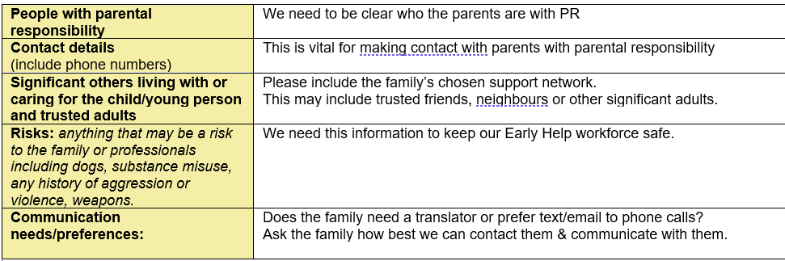

**Agencies/Professionals involved**

This section helps to understand the professional support network around the family, the support already in place for the family or has been referred to.

**Education-specific information**

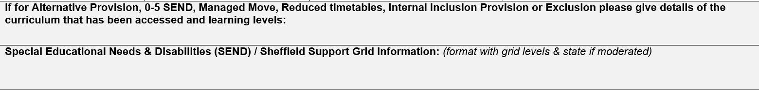This section only needs to be completed if the assessment includes school-aged children with Special Educational Needs.

**Important/Significant Life Events**

Are there significant life events that professionals need to be aware of that are affecting the child, young person or family? These could include bereavements, parental separation, recent house moves or adverse childhood experiences.

**Young Carers**

The Children & Families Act 2014 defined a young carer as ‘a person under 18 who provides or intends to provide care for another person’. This can be emotional and/or practical support because that person has disabilities, long-term physical illnesses, mental health difficulties and/or drug or alcohol issues. If a Young Carer has been identified, they should be offered a separate Young Carers Assessment [Young carer assessment | Sheffield City Council](https://www.sheffield.gov.uk/social-care/young-carers-assessment)

**Previous Early Help Support**

This section helps to give some background to whether this is the first time this family have needed additional support, or whether there has been additional help and support provided by other agencies in the past. If there has been recent Early Help Support, please state which agencies were involved, what they did and what difference it made to the family.

**Family Scaling Question**

This question gives a quick and easy snapshot of how worried (or not) the family are about the current situation. This may well differ from the view of the involved professionals.

**Child/Young Person’s Voice**

The wishes & feelings of the child/young person should be gained by an adult that they know well and trust. This does not necessarily need to be the person undertaking the rest of the assessment with the parent/carer. Add more lines if needed for more children/young people.

There is additional training available in gaining the Voice of the Child – for details of this and other training available for anyone who works with children, young people & families see [Early Help Workforce Training | Sheffield (sheffielddirectory.org.uk)](https://www.sheffielddirectory.org.uk/children-and-families/learning-working-and-volunteering/early-help-workforce-training/)

If the child is an unborn than this section can be used to describe how parents interact with the bump and how they speak about becoming a parent.

If the child is non-verbal then an observation from a visit can be used.

**Parent & Professionals Voice**

This section is where the assessment of what’s going well, what are people worried about, and what needs to happen are stated. This aligns with the Signs of Safety practice model used across the Sheffield Children’s Services.

Ideally this will all have been discussed at a Team Around the Family meeting.

The table splits the assessment across the 4 domains of Education/Training & Employment, Health, Independence Skills, and Care, Family & Community Factors.

This aligns with the 4 Pillars of Preparation for Adulthood and helps to determine which type of agency may be best placed to meet any additional or unmet needs of the family.

*Image produced by the National Development Team for Inclusion*: [Preparing for Adulthood - NDTi](https://www.ndti.org.uk/projects/preparing-for-adulthood)

Independent living can include whether the child/young person is able to travel to school independently, get themselves dressed independently and/or prepare their own snacks or meals.

For children under the age of 5 then in the “independent” section information on child/foetus development can be added. This could include any information from their last scan/development check.

All sections can contain information on everyone in the family. If an adult needs support around employment please include this. If there is an adult living in the house who isn’t a parent (for example an adult sibling) then they can also be included in the assessment.

**What to do with the assessment?**

Your next steps will depend on the level of need of the child/family.

**Level 1: Universal Services**

It may be that having completed the assessment you have established with the family that any additional support needs they have can be met by the agencies already involved with the family. In which case, you may feel that holding a review meeting with the family or Team Around the Family meeting in a few weeks time would be helpful.

**Level 2: Getting Help**

If the assessment process has established some emerging needs then you may find the additional service that can supplement the existing professional support network by looking at the Sheffield Directory [Home Page | Sheffield (sheffielddirectory.org.uk)](https://www.sheffielddirectory.org.uk/)

**Level 3: Targeted Support**

If the assessment has revealed multiple complex issues then it is likely that a targeted Early Help support service will be needed. Discuss and gain consent from the family to send your assessment to [EarlyHelpAssessment@sheffield.gov.uk](mailto:EarlyHelpAssessment@sheffield.gov.uk) and an Early Help specialist practitioner will recommend the right Early Help service to meet the needs of the family, in liaison with the family’s chosen support network and the professional support network.

**Level 4: Statutory & Complex**

If the assessment has made you concerned that a child is at risk of significant harm then you need to follow your agency’s safeguarding procedures.

Additional information at [Sheffield Children Safeguarding Partnership - (safeguardingsheffieldchildren.org)](https://www.safeguardingsheffieldchildren.org/scsp/processes/referring-a-safeguarding-concern-to-childrens-social-care)