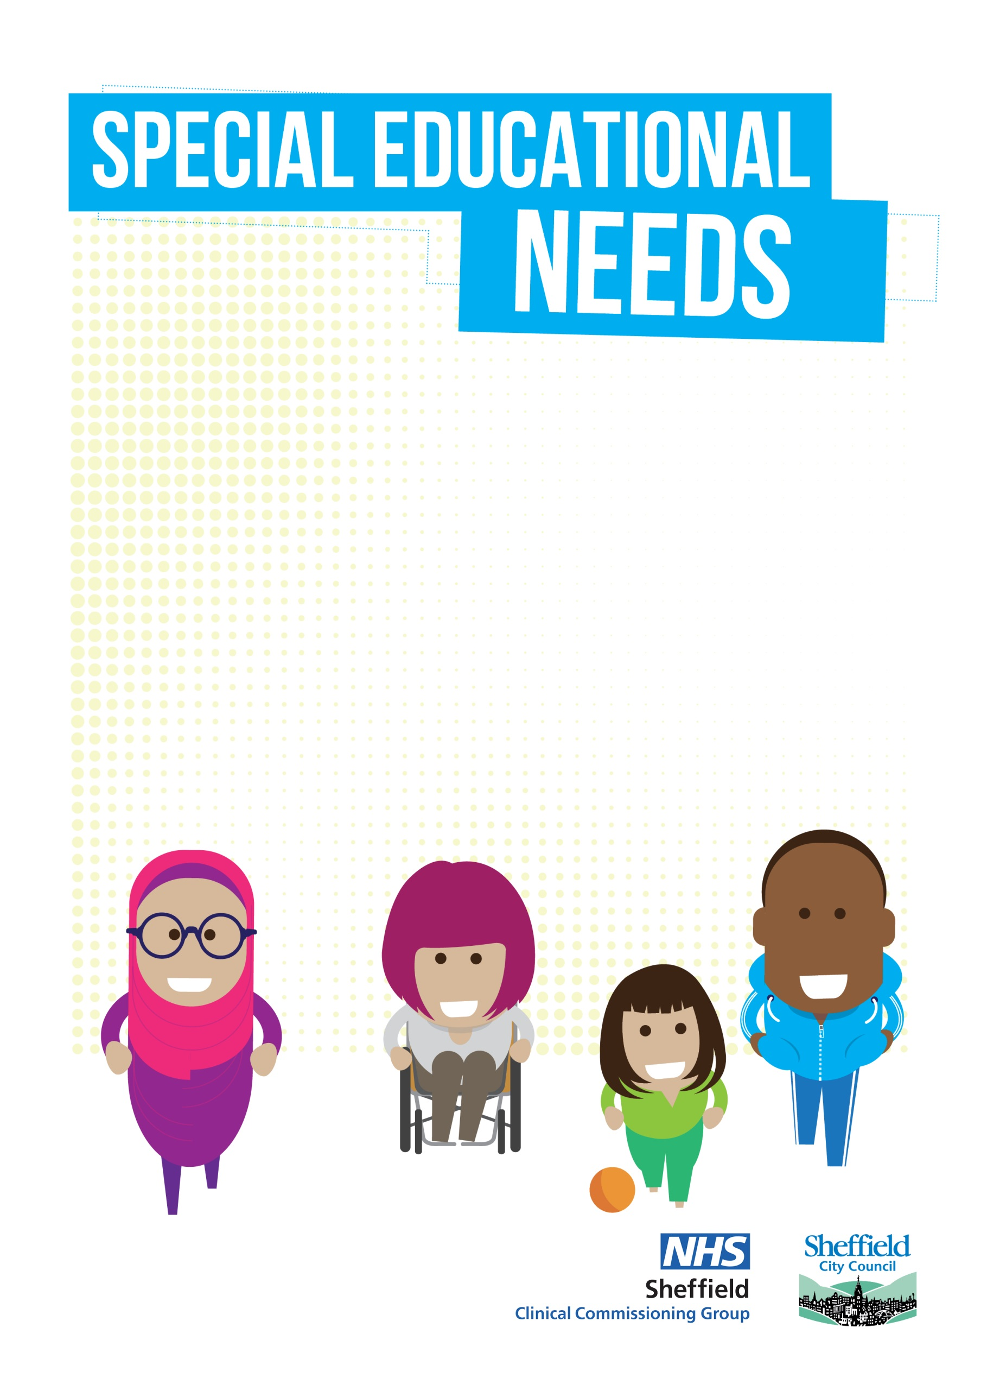

**Sheffield transition principles to support children and young people**

**- including/in particular those with Special Educational Needs**

**Sheffield transition principles to support children and young people**

Children and young people go through lots of transition points. This includes moving between classes, schools, support services and ultimately into adult life.

The following principles have been co-produced in Sheffield. They aim to help us create best practice as we support children and young people going through significant transitions. They have been developed to particularly support those with additional needs. This is because children and young people with special educational needs and disabilities will need earlier and more detailed planning for transition to be successful.

**Definition:**

We define transition as: Any time in a child or young person’s life where there is a planned change that needs to be effectively prepared for, so that they can be happy and fulfilled. This includes transitions across Education, Health and Care.

**To ensure good transition we will:**

* Put the child or young person and their family’s voice and aspirations at the centre of all planning for transition.
* Make sure future transitions are considered and planned for in everything we do to support children and young people to achieve their potential.
* Plan and prepare for transition points as early as possible. Understand that transition is an ongoing process. Children, young people, and their families need good advice and guidance throughout. Plans of support should be co-produced with them.
* Expect clear communication between the child or young person, their family, education providers and support services. This is to make sure that everyone is clear about what will happen and when.
* Expect both current and future providers or services to work together and talk to each other to make sure that a transition is successful.
* Have clear timescales for each child or young person. These will cover when transition planning and preparation is needed, and when information will be shared.
* Make sure information shared between providers and services is clear, concise, appropriate and includes everything needed, so that a ‘tell us once’ approach can be taken. Make sure the information is read and used to plan for supporting the child or young person.
* Expect all providers and services to have information that clearly explains the transition process. They should make this available in different formats and share it with everyone who needs it.

These transition principles were produced on behalf of Sheffield’s Inclusion Improvement Board. They were approved in March 2022.