**What Sheffield Family Hubs offer**

**Family Hubs are accessible, welcoming, and warm spaces. We deliver activities for children aged 0-5 and offer help, signposting, and support to parents/carers of children aged 0-19, or up to 25 for those with special educational needs and disabilities.**

There are 7 hubs which, together with community venues, outreach sites and network centres, cover all areas of Sheffield. Families can attend any event at any family hub, our Hubs offer:

* preparation for birth and beyond groups
* health support and clinics delivered by Midwives and Health Visitors
* breastfeeding support groups and drop ins
* ‘walk and talk’ sessions
* baby massage
* baby and toddler groups
* early language and home learning activities for under 5s

Families can also get help and support with:

* getting into work or training
* weaning, toilet training, oral health, etc.
* support with private and social housing issues.
* stopping smoking
* benefits and Cost of Living Support
* parenting support
* mental health support
* domestic abuse support

**One to One support**

As well as our activities and groups, we have Early Years Prevention workers who can offer extra help to families, supporting with a child’s behaviour, accessing support around children with additional needs and accessing housing and benefits advice.

If you know a family which could benefit from this, please contact [SheffieldFamilyHubs@sheffield.gov.uk](mailto:SheffieldFamilyHubs@sheffield.gov.uk) to discuss how we may be able to help.

**Early Help Services**

If a family has several needs, or whose circumstances might make them more vulnerable, they could receive early help from one or more services, such as:

* Health Visiting and School Nursing
* Family Hubs and Early Years
* Family Intervention Service
* Parenting Hub
* SEND Services

Services - including education settings - can refer families using an [Early Help Assessment Form](https://www.sheffielddirectory.org.uk/media/wk5ohx0v/eha-january-2024.docx), or families can self-refer by calling (0114) 203 7485.

* Access and Inclusion
* Community Youth Services
* Housing
* Police
* Employment Services

**What the Infant Feeding Team can offer schools**

**Free education sessions for Primary and Secondary schools**

“The Benefits of Breastfeeding” is a tailor-made scheme of work developed by a qualified teacher as part of the Infant Feeding team to promote breastfeeding to wider partners. Sessions are linked with the **Biology and PSHE curriculum** to deliver a cross-curricular education.

Through this **education programme**, targeted at **Year 5 and KS3 students**, we aim to:

* Raise awareness of the health benefits of breastfeeding
* Remind children that we are mammals and breastfeeding is natural
* Educate about the personal financial benefits of breastfeeding
* Inform about global environmental benefits of breastfeeding.
* Improve attitudes towards breastfeeding

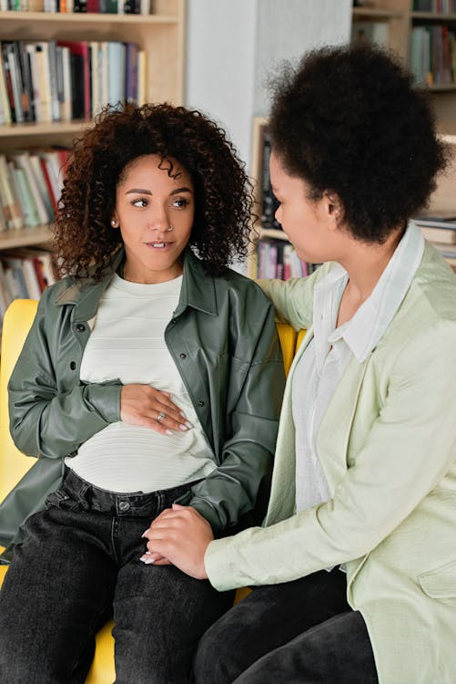

**Coffee mornings and family education sessions**

Our workers can meet with families, introduce Family Hubs and signpost them to other services as needed.

Family education sessions, designed for the whole family/support network, are aimed at those who want more information about the facts and myths of feeding and caring for a baby, whether they’re pregnant or just thinking about having a baby in the future.

**Free training to become a Breastfeeding Friendly workplace/public space**

Support your staff and community by becoming one of Sheffield’s ‘Breastfeeding Friendly’ venues. Support with creating a welcoming breastfeeding- friendly environment and setting up policies.

For more information on what the Infant Feeding team can offer, please email [infantfeedingsupport@sheffield.gov.uk](mailto:infantfeedingsupport@sheffield.gov.uk)